.École John W. MacLeod Fleming Tower School
School Supply List
Grade 3 and 4 English
2023-2024
Please recycle and reuse. It’s not always necessary to buy new supplies. If you have items from last year that can be used again, please feel free to use them. School supplies are necessary but expensive. If due to financial constraints you anticipate having difficulty purchasing all or some of the items listed above please contact the principal at 479-4438.

The following is a list of supplies your child will need to begin the school year. More supplies may be needed as the year progresses.
- Please clearly label all of your child’s supplies to help avoid confusion or loss.
- 1 erasable pen
- 1 highlighter
- 1 black Sharpie marker
- 1 scotch tape
- 2 package of pencils- Sharpened please (HB only)
- 2 eraser
- 1X 30cm ruler ( not bendy please)
- 1 small whiteboard ( approximately 8 x 10)
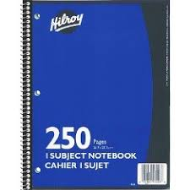
- 8 whiteboard markers for personal use ( bring 4 save others for later)
- 1 whiteboard eraser ( old cloth or sock could work)
- 1 large glue stick
- 1 package of coloured pencils and 1 package of markers
- 1 art sketchbook- (please reuse from last year if pages still exist)
- 1 pair of scissors
- 1 plastic kit box - standard size - the large ones will not fit in the desk
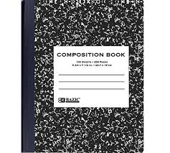
- 1 pencil sharpener with a closed lid
- 1 pair of earbuds or earphones, placed in small Ziplock with name on front
- 2 plastic pocket folders without metal rungs (Red and Blue if possible)
- 2 duotangs with metal rungs
- 1 X COILED Hilroy scribblers (250 pages)
- 1 X small writing composition book ( Label Writer’s Notebook)
- 4 thin Hilroy scribblers
- Indoor shoes
OPTIONAL, BUT APPRECIATED:
- Unscented baby wipes (to wipe hands/desks etc. during cold + flu season)
- Hand Sanitizer
- Box of tissues

