John W. MacLeod Fleming Tower School 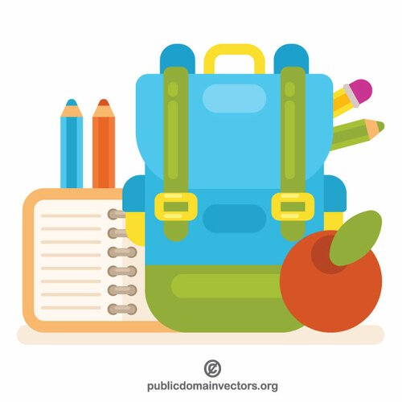
Grade 2 English - School Supply List - 2023-2024

The following is a list of supplies your child will need for the school year. Please clearly label all your child’s supplies to avoid loss. It is extremely helpful to bring all supplies in an extra-large ziplock bag labelled with your child's name the first day. Feel free to reuse supplies from last year.
If possible, in your child's pencil box please remove from packaging and put 2 pencils, an eraser, their scissors, 1 white board marker, 1 Sharpie and the box of crayons.
- 3 large glue sticks
- 1 pack of coloured pencils (sharpened)
- 2 package of 12 regular pencils – sharpened
- 3 EXPO white board markers for personal use
- 1 white board eraser (a piece of cloth or old sock will do)
- 2 white erasers
- 1 quality pencil box or pencil case
- 1 quality pencil sharpener
- 2 black Sharpies
- 1 pair of quality children’s scissors
- 1 package of markers
- 1 package of crayons
- 1 small yellow Hilroy exercise book (half lined-half white)
- 2 small green Hilroy exercise book (half lined-half white)
- 2 scribblers (Hilroy, not coiled)
- 5 pocket folders (Red, Green, Blue, Yellow, Orange)
- 1 1-inch three-ring binder
- A zipped message/courier bag (Dollar store)
- 1 pair of earphones to use with a chromebook, in a Ziplock bag, labelled (pls label the bag and the earphones)

Students will also need:
- 1 pair of indoor sneakers
- 1 school bag
- 1 reusable plastic water bottle

Donations for the following are most welcome:
- A box of tissue
- A package of scentless baby wipes

