School Supply List
Grade 1 French Immersion
John W. MacLeod-Fleming Tower School
2023-2024

Important notes
- This is a basic list, common to all French Immersion grade one classes.

- In September, individual teachers will send home a request for any other supplies that are needed in that particular classroom.

- Thank you in advance for carefully reading the information and notes below. Your attention to detail saves teachers countless hours when trying to organize so many bags and items during the first few days of school. Your help is very much appreciated!

- If it is difficult for you to buy supplies because of your financial situation, please do not hesitate to contact admin! We are here to help you and your child.

- Conversely, if you would like to donate any extra supplies, that would be appreciated! Please label any supplies designated as donations. Thank you in advance! ☺️

How to label and bag supplies
- LABEL most of your child’s supplies with permanent marker
  - Exceptions: do not label:
    - pencils, glue sticks, white glue, and Sharpies

- REMOVE all packaging from supplies.

- Place certain supplies (noted below) in an extra-large Ziploc bag (available at Dollar Store)
    - Why? Your child’s extra supplies will be stored in this large ziploc in a bin with other students’ extra supplies.

Items for the extra-large Ziploc bag
**please clearly label the Ziploc with your child’s name**
- 1 large glue stick (do not label with your child’s name, please)
- 1 bottle of white glue (do not label with your child’s name, please)
- 2 packs of crayons (24 pack)
- 1 pack of coloured pencils (24 pack)
- 1 package of large (not thin) markers (unscented, washable).
- 2 white erasers (large)
- 2 pairs of scissors
- 24 HB pencils- sharpened please (HB as others break easily and do not stay sharpened)
(Please do not send unsharpened pencils. Please do not label pencils with child’s name.)

- 12 large whiteboard markers (such as regular-sized Expo markers. Please do not send mini-sized markers).

- 2 whiteboard erasers or two old, clean socks to use as erasers.
- 2 regular-sized (not jumbo) Sharpie permanent markers, black (do not label with your child’s name, please)
- 2 pencil sharpeners
- 2 thin highlighters (used for printing practice). Please do not send fat ones.

(over)

Items for a separate bag
(such as a reusable grocery bag)
- 1 canvas zippered messenger/courier bag**
**this item is an absolute must. These are available at the Dollar Store.
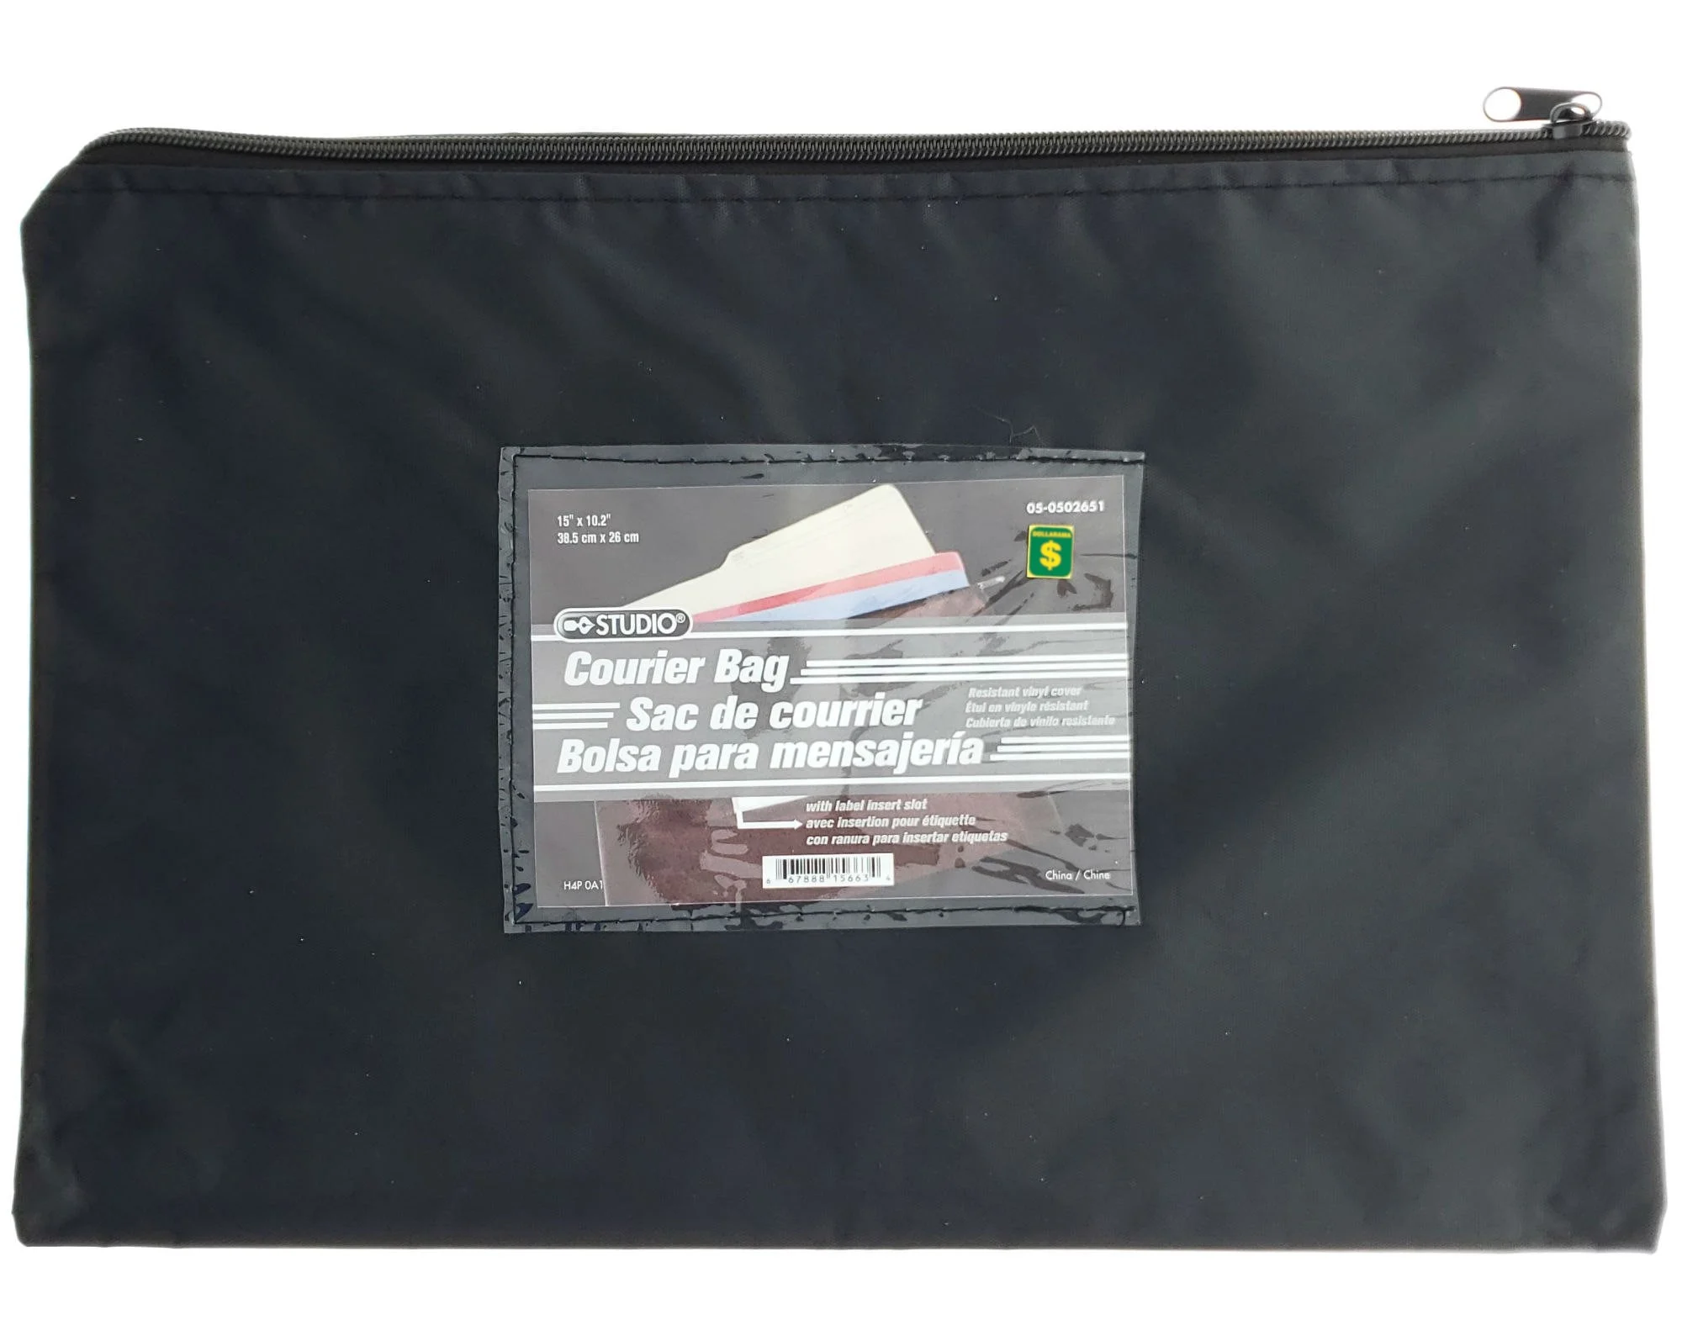
- 1 plastic pencil box
- 3 duotangs
- 1 small yellow Hilroy exercise book (half lined, half plain).

- 2 pocket folders
  - Important notes:
    - Ensure that they do indeed have pockets on the insides - these are used for writing folders and are not the same as duotangs.
    - DO NOT buy the folders with duotang bindings in the middle. These get in the way of organizing papers and can create real difficulty for a grade one student trying to organize her/his work.
    - Good examples of the type of folders we need:
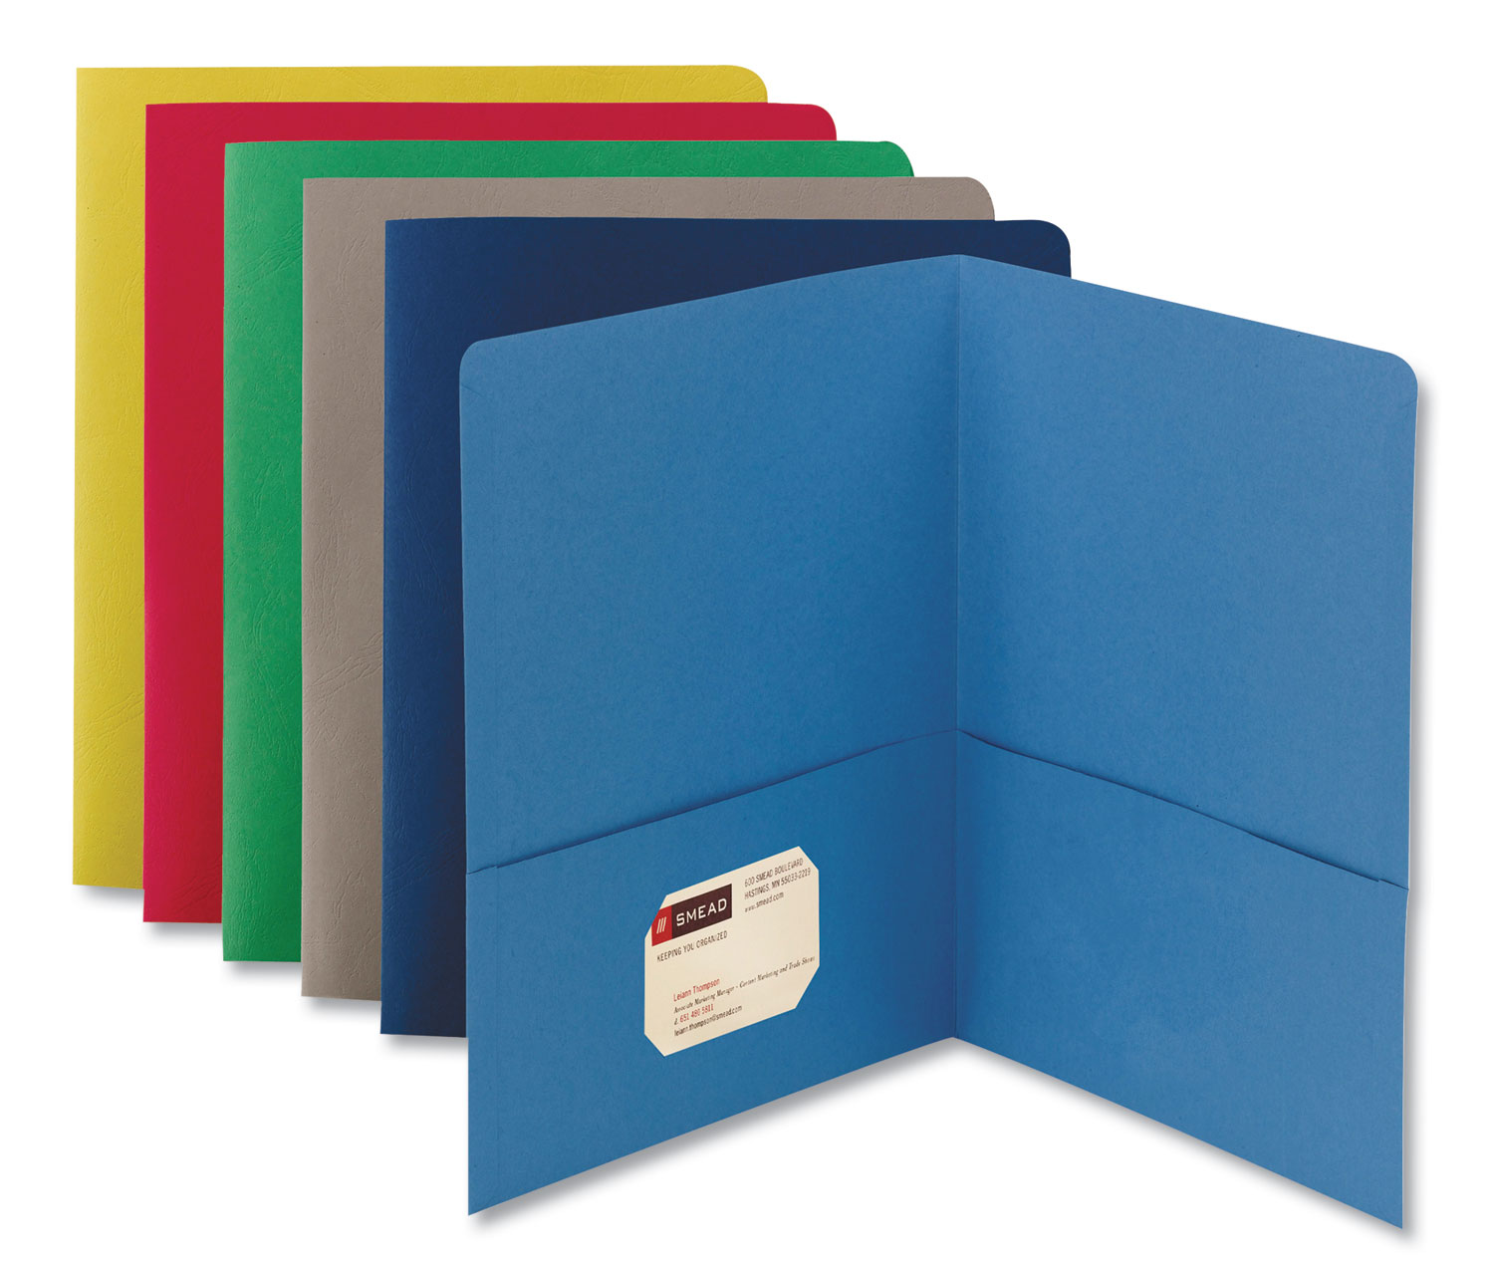
(over)

Items for a separate bag con’t
- 1 white board - blank, unlined, regular-sized (ie not mini).
  - Note that the ones from the Dollar Store often fall apart quickly.
  - Example of size:

- 1 clipboard big enough for a regular 8x11 piece of paper. Example:

- 1 set of headphones, preferably ones that cover the ears, rather than earbuds, which can be difficult for young learners. These will be used with Chomebooks, but not until after Christmas, so no worries if you can’t get them right away.

- 1 pair of indoor shoes to keep at school, clearly labeled with permanent marker.
- 1 bag of extra clothes in case of accidents, clearly labeled on tags:
  - underwear
  - socks
  - shirt
  - pants (such as tights or jogging pants)
Donations of the following would be VERY much appreciated! Thank you in advance!!
- Large, medium, and small Ziploc bags
- Boxes of Kleenex
- Packages of baby wipes (not Clorox wipes)

