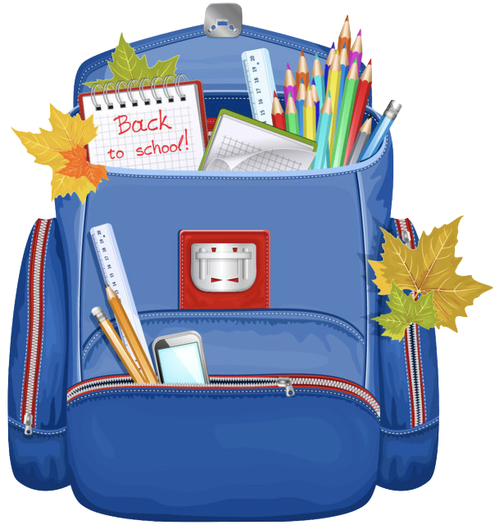
École John W. MacLeod - Fleming Tower School
Grade One English School Supply List
2023-2024

1 backpack
1 lunch box
1 pair of indoor sneakers (Velcro please)
1 water bottle – reusable to come to school each day with water from home
1 change of clothes in Ziplock bag (socks, pants/shorts, shirt, underwear)
(Please LABEL all of the above items with your child’s name)

4 - two pocket glossy plastic folders for specific subjects- no duotangs holes/ fasteners please (any colours)
2 - Green Hilroy scribblers (½ interlined and ½ blank pages)
2 - Dark Blue Hilroy scribblers (blank pages)
2 - glue sticks
2 - pack of markers
2 - pack pencil crayons (24 packs)
1 - pack of whiteboard markers
2 - white erasers
2 - pack of sharpened pencils
1 - pair of scissors
1 - box of ziplock bags
2 - boxes of tissues
1 - zipper messenger bag (found a dollerama)

See you in September!

