École John W. MacLeod - Fleming Tower School
Grade Two French School Supply List
2026-2027

1 backpack
1 lunch box
1 pair of indoor sneakers (Velcro please unless student can tie independently)
1 water bottle – reusable to come to school each day with water from home
1 change of clothes in Ziplock bag (socks, pants/shorts, shirt, underwear)
(Please LABEL all of the above items with your child’s name.

Items below please do NOT label. Thank you! )
4 - plastic folders for specific subjects (WITH duotangs holes/ fasteners)  1 Red (preferred)  1 Blue (preferred)  1 Green (preferred)  1 Yellow (preferred) | 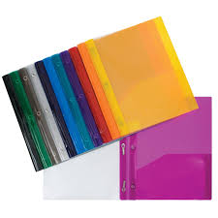
2 - Green Hilroy scribblers (½ interlined and ½ blank pages) | 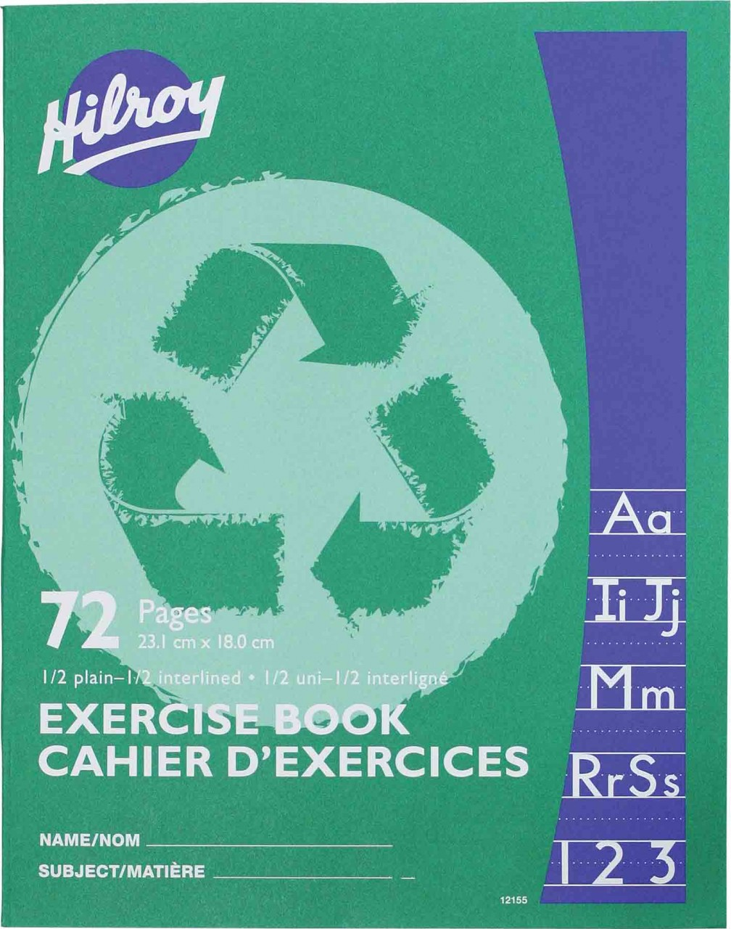
1 - Yellow Hilroy scribbler | 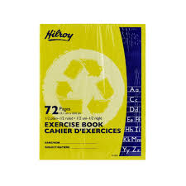
3 - glue sticks | 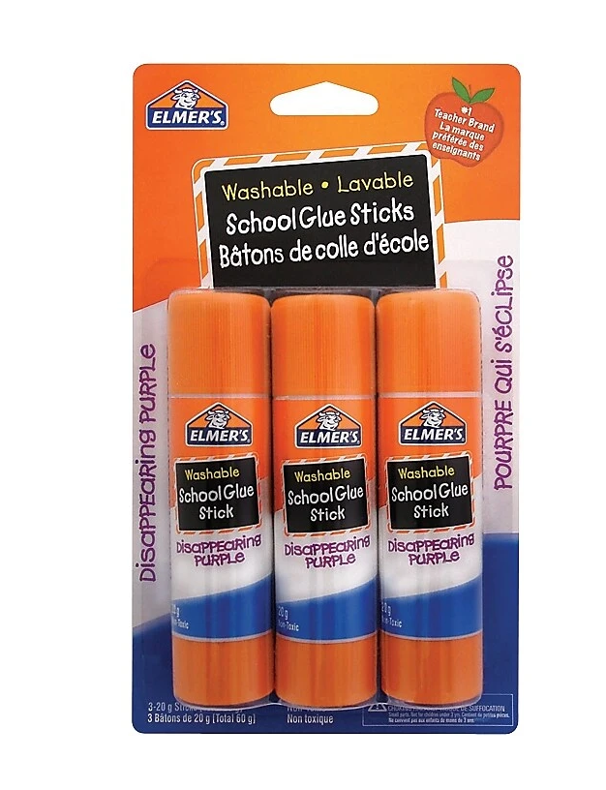
1 - pack of washable markers | 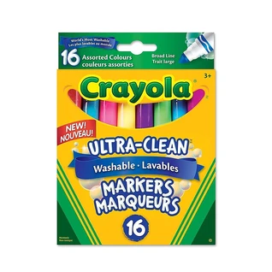
1 - 24 packs pencil crayons | 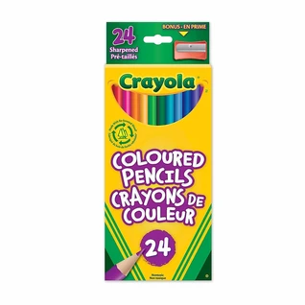
4 - white erasers | 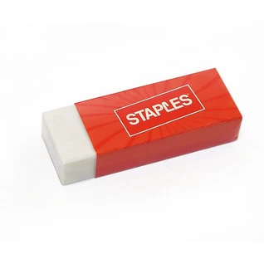
1 - pair of scissors | 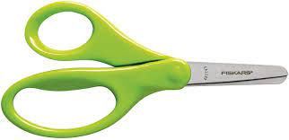
1 - zipper messenger bag or laptop sleeve (found at dollarama) | 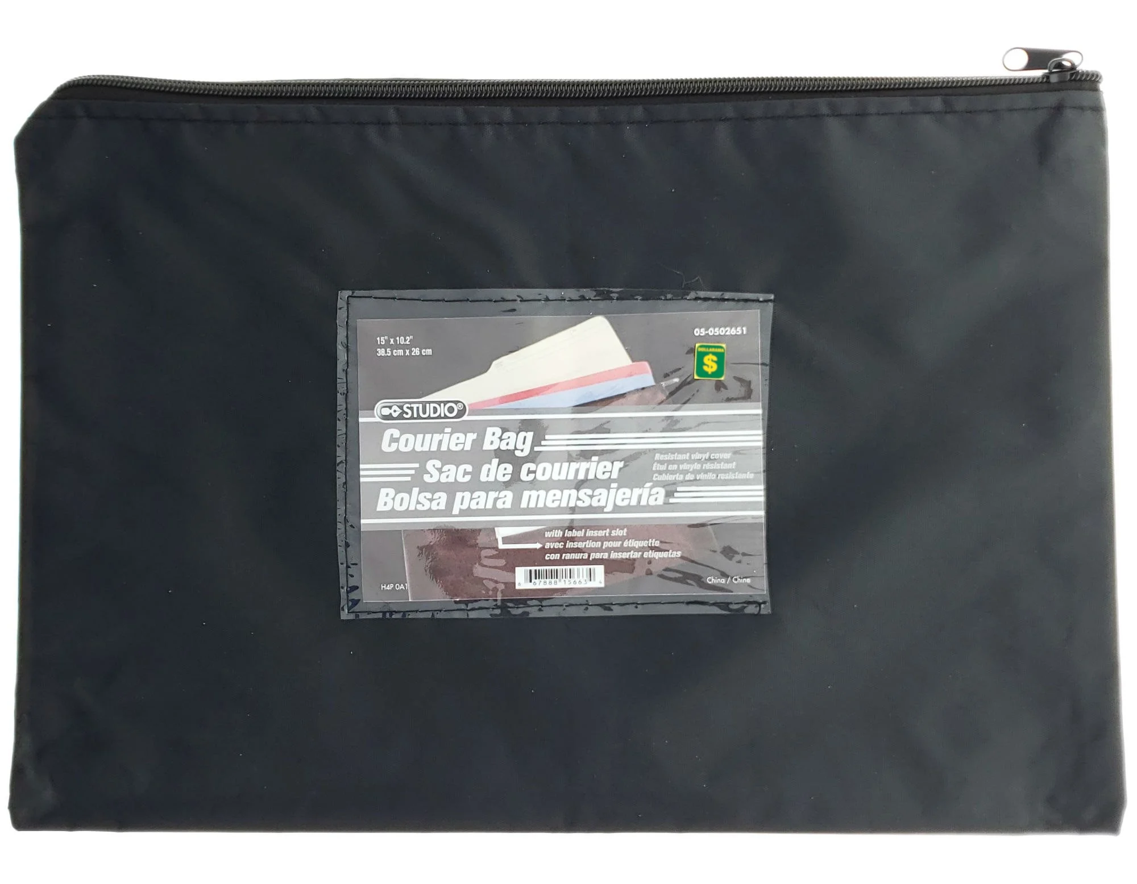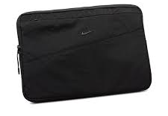
3 - black sharpies | 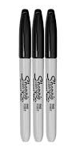

Optional but appreciated:
box of large ziplock bags
boxes of tissues
Whiteboard markers

Please recycle and reuse. It’s not always necessary to buy new supplies. If you have items from last year that can be used again, please feel free to use them. If due to financial constraints you anticipate having difficulty purchasing all or some of the items listed above please contact the principal at 479-4438. We are happy to help :)

