École John W. MacLeod - Fleming Tower School
Grade Primary English School Supply List
2026-2027

1 backpack
1 lunch box
1 pair of indoor sneakers (Velcro please unless student can tie independently)
1 water bottle – reusable to come to school each day with water from home
1 change of clothes in Ziplock bag (socks, pants/shorts, shirt, underwear)
(Please LABEL all of the above items with your child’s name)

2 - two pocket glossy plastic folders for specific subjects (no duotangs holes/ fasteners)  2- plain duotangs | 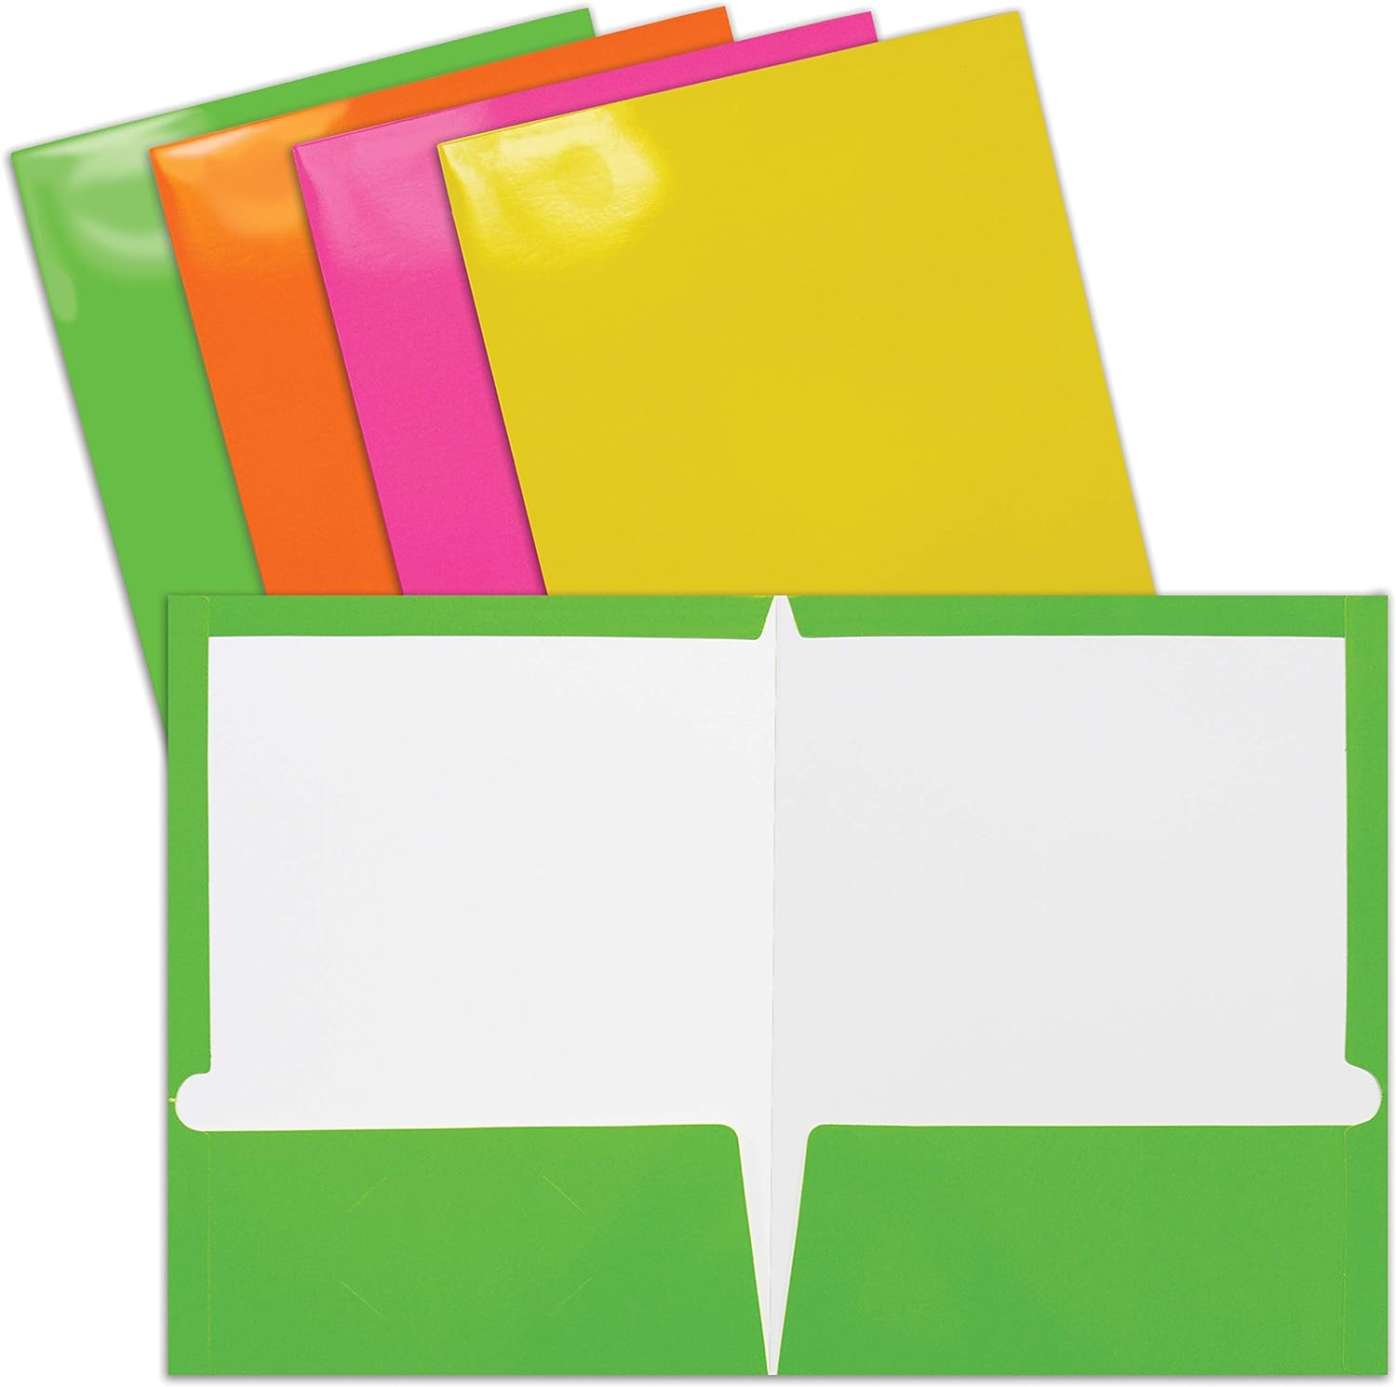
1- Blue Hilroy scribbler (solid white paper)  1 - Green Hilroy scribblers (½ interlined and ½ blank pages) | 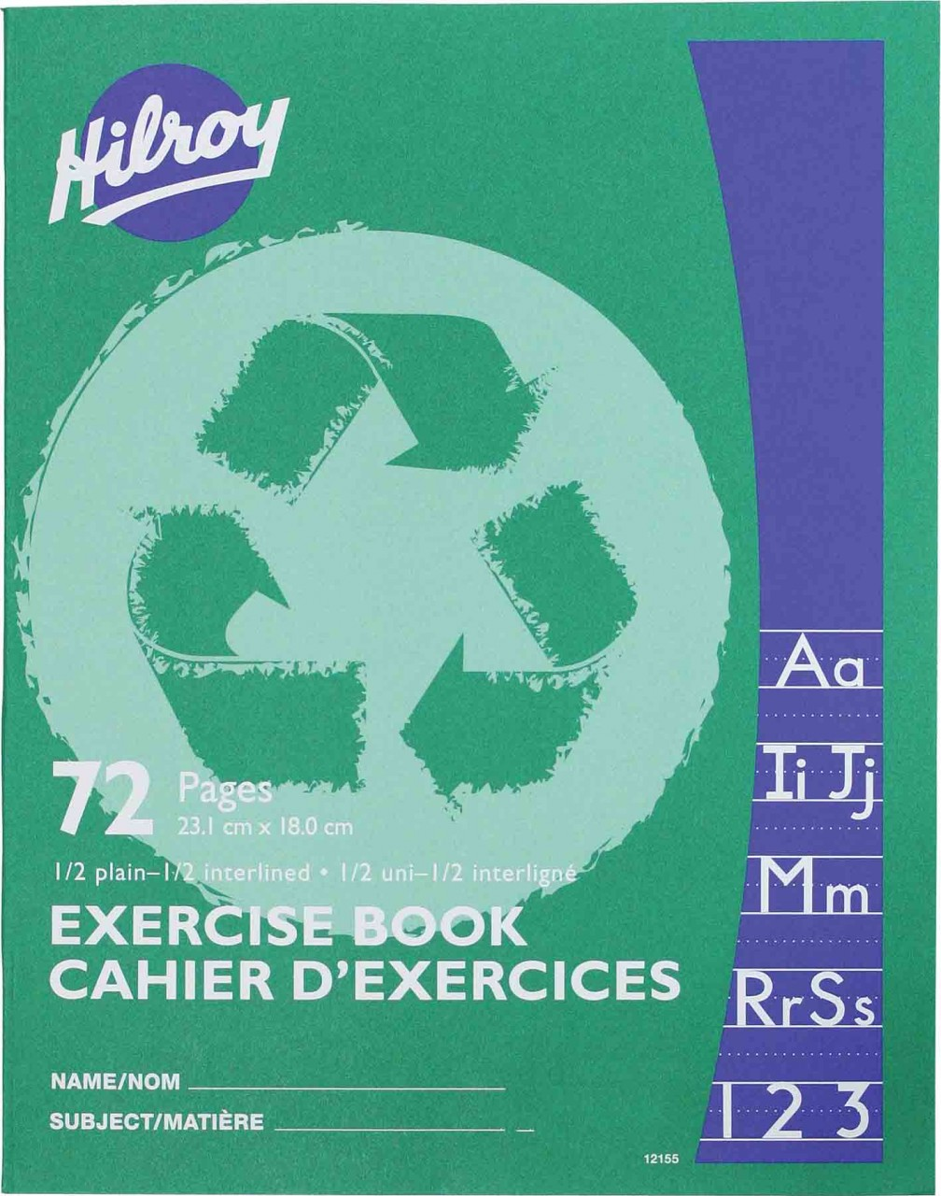
3 - large glue sticks | 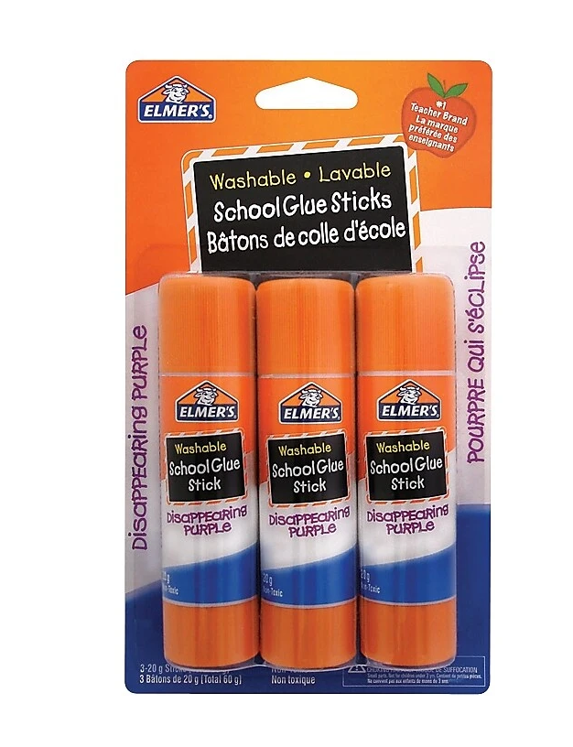
2 - pack of markers | 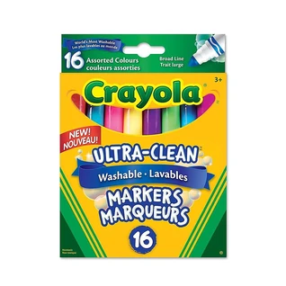
2 - 24 packs crayons  1- pack of colored pencils | 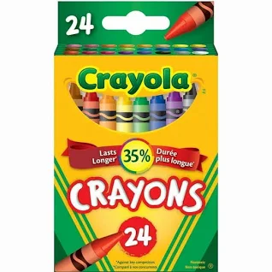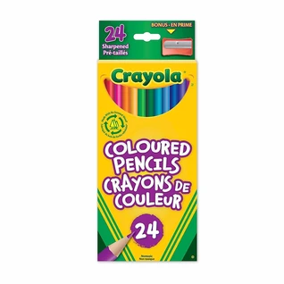
3 - white erasers | 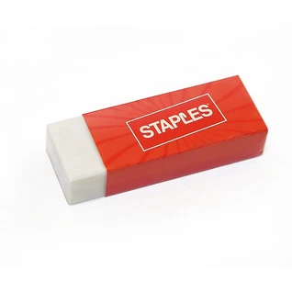
1 - pair of scissors (if your child is left handed, please purchase left handed scissors) | 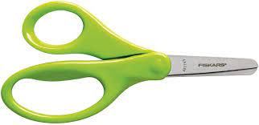
1 - zipper messenger bag (found at dollarama) | 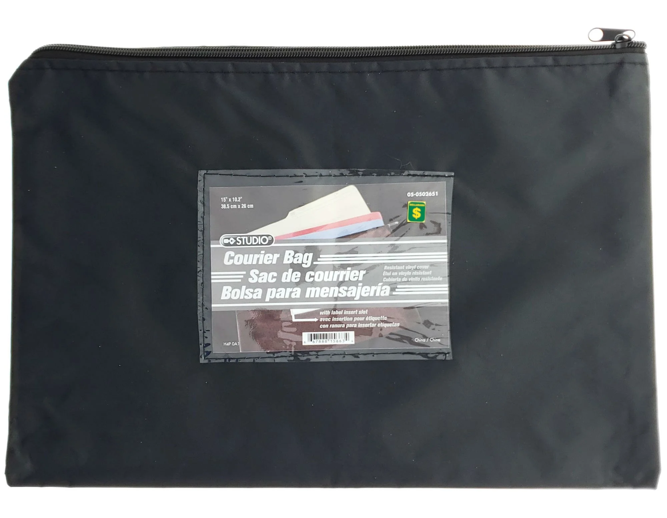
- Please put all supplies in a large ziplock bag with your child’s name
Optional but appreciated:
1 - box of large ziplock bags
2 - boxes of tissues or wet wipes
4 - Whiteboard markers

