JWMFT School Supplies for Grade 5 English
2026-2027

It is not always necessary to buy new supplies. If you have items from last year that can be used again, please feel free to reuse them. Thank you in advance for purchasing these items. If due to financial constraints you anticipate having difficulty purchasing all or some of the items listed above please contact the principal at 479-4437.🙂
* Please label all items with your child’s name

Item name | A visual to help in purchasing  (please note this is just a suggestion and specific brands are not required)
1 large pencil case | 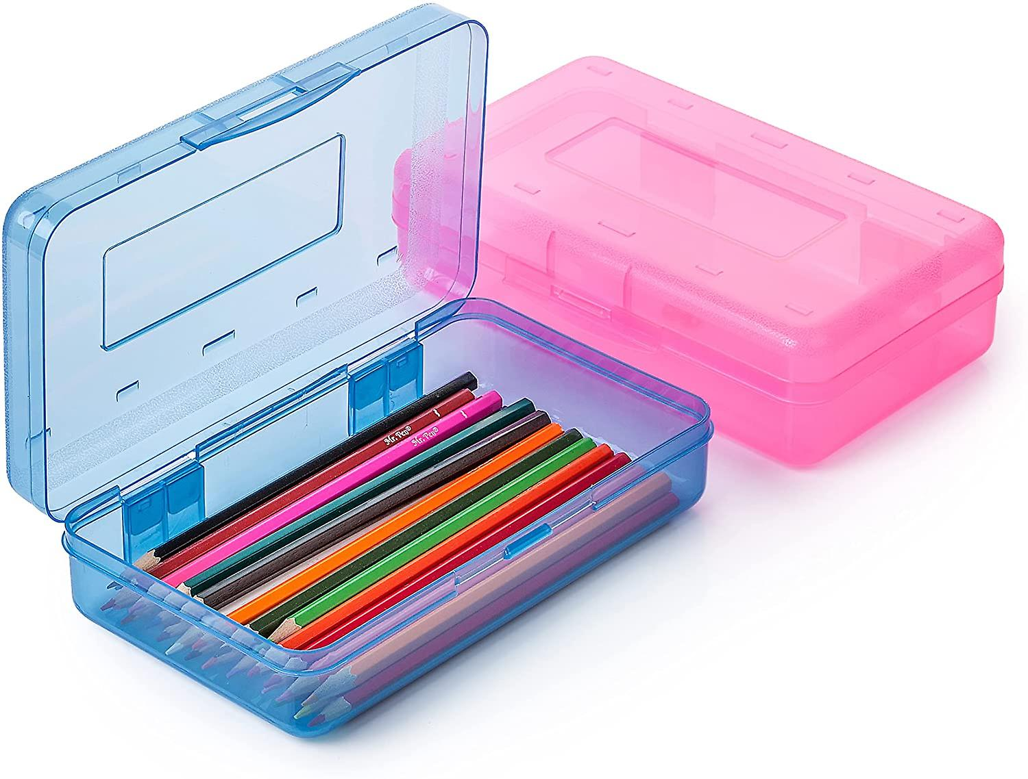
3 duotangs | 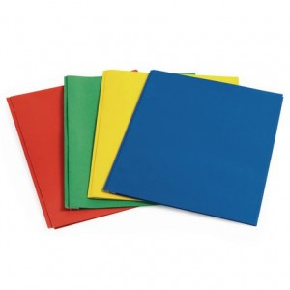
1 pocket folders(with no metals clips) | 
1 composition notebook | 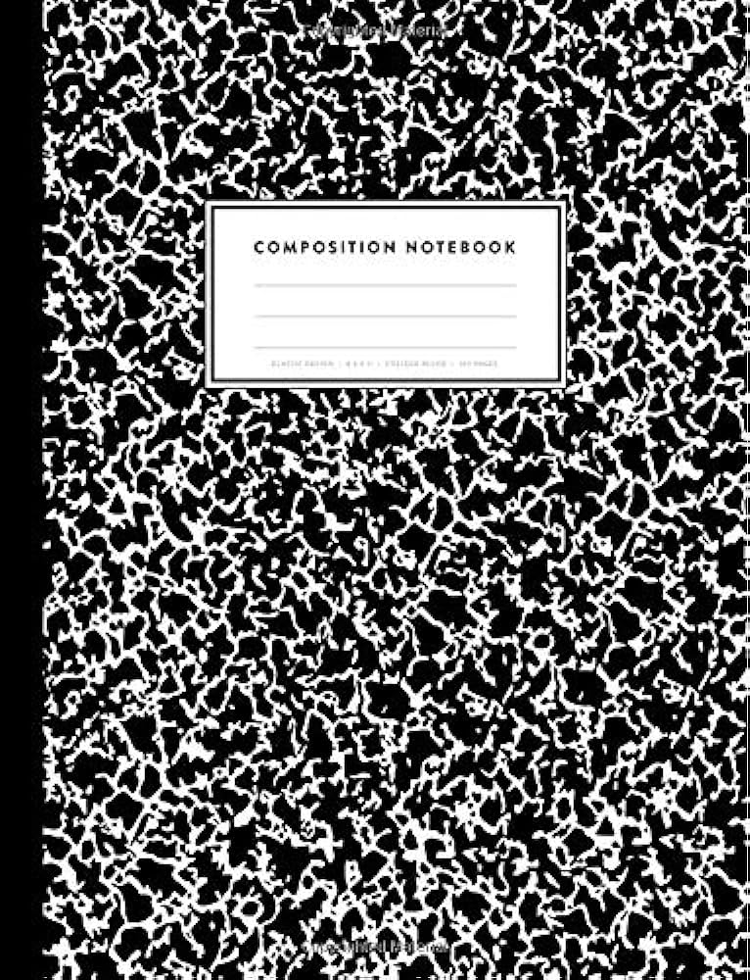
1 package of 4 thin scribblers with full lines. Not half and half. | 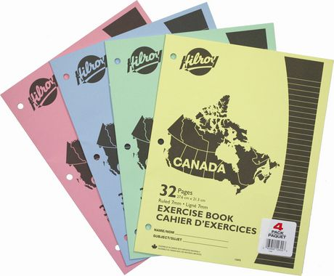
1 coiled scribbler (250 or 300 pages) | 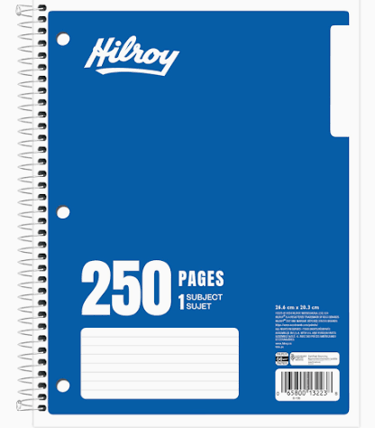
1 package of markers | 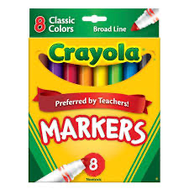
1 package of coloured pencils | 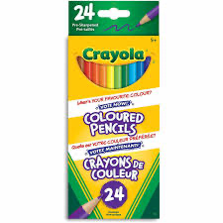
2 white erasers | 
1 highlighter | 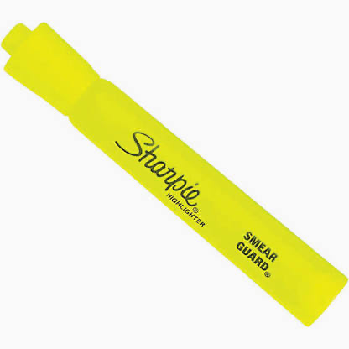
1 pencil sharpener with lid | 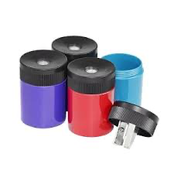
1 pair of headphones/earbuds  (inexpensive pair kept at school) | 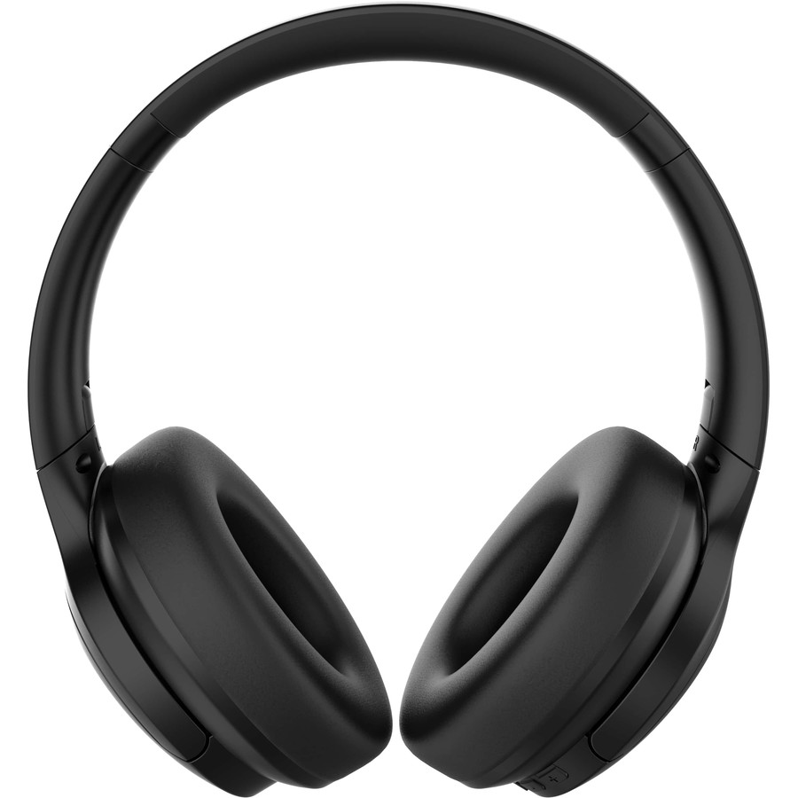
Optional but appreciated:
- Boxes of tissues -baby wipes
- Ziplock bags

