École John W. MacLeod - Fleming Tower School
Grade 3 English School Supply List
2026-2027
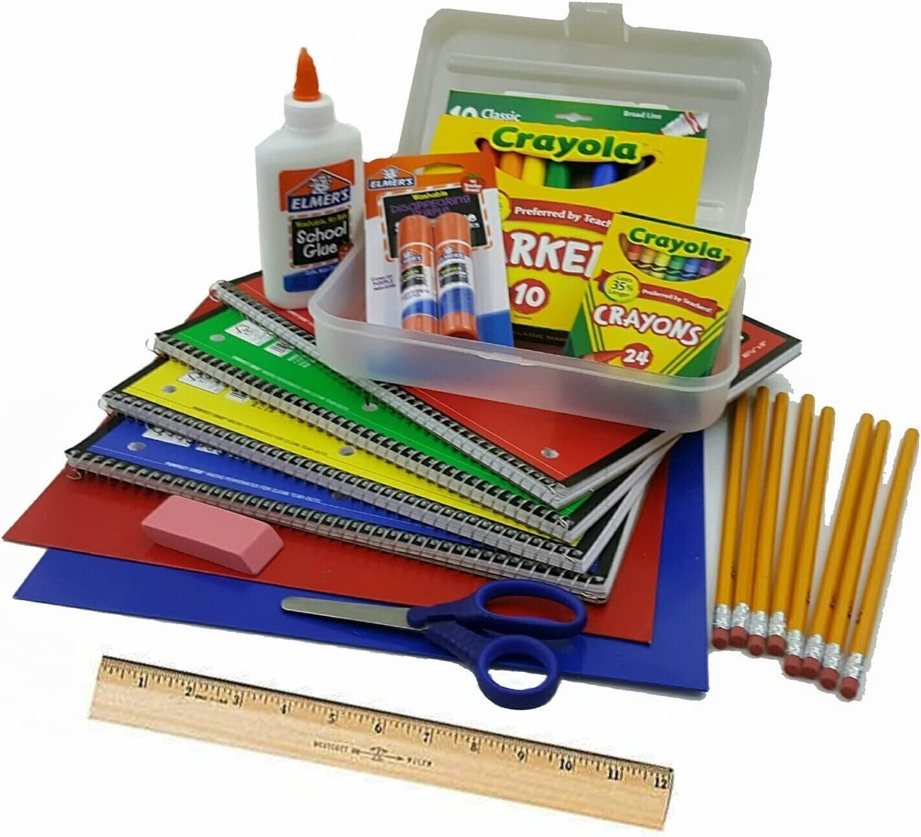

Important Information
Please note: This is a general supply list for all Grade 2 English classes. Individual teachers may request additional items in September based on the needs of their classroom.
If purchasing these supplies presents a financial hardship, please contact the school. We are committed to supporting all families and are happy to help.

Before Sending Supplies to School
Please:
- Label all supplies with your child's name using a permanent marker, except where otherwise indicated.
- Remove all packaging from supplies.
- Place designated supplies in an extra-large Ziploc bag (available at most dollar stores).
  - Extra supplies will be stored in this bag throughout the school year. Clear bags make it easy for teachers to identify and organize student materials.
- Send a reusable grocery bag for additional classroom items (see below).

Supplies to Place in the Extra-Large Ziploc Bag
(Clearly label the bag with your child's name.)
- 1 pencil sharpener
- One green, yellow,orange and pink highlighter
- One plastic pocket folder
- One pack of colour pencils
- One pack of markers
- One 3 ring binder

Supplies to Place in a Separate Reusable Grocery Bag

Daily Use Items
- 1 canvas zippered messenger/courier bag
  - This item is required and will be used every day.
  - Available at most dollar stores.
- 1 pencil box
  - Large enough to hold:
    - 4 pencils
    - 1 eraser
    - scissors
    - pencil sharpener

Writing and Learning Materials
- 2 regular-sized Hilroy exercise notebooks
  - Approximately 80 pages
  - Size: 27.6 cm × 21.2 cm
- 2 Hilroy scribblers
  - Half interlined pages / half blank pages
- 4 duotangs
- 2 pocket folders (not duotangs)
  - Must have inside pockets.
  - These folders are used for writing activities and are different from duotangs.
  - Folders without prongs are preferred, as papers fit more securely inside.

Personal Items
- 1 pair of indoor shoes
  - To remain at school throughout the year.
  - Clearly label with your child's name.
- 1 set of headphones
  - Over-ear headphones are preferred over earbuds, as they are easier for young students to use.

Optional Classroom Donations
The following items are greatly appreciated but completely optional. Please do not feel any obligation to purchase them.
Thank you for supporting our classroom community!
- Ziploc bags (small, medium, or large)
- Kleenex tissues
- Unscented baby wipes

